**EPPO-REUFIS-BFW Conference**

**‘Safeguarding Forests in Europe: Emerging Risks of *Agrilus* Wood Borers (Buprestidae)‘**

**Vienna, 21–23 April 2026**

**Accommodation**

The conference will take place on the 21st to the 23rd of April, 2026 at BFW, [**Seckendorff-Gudent-Weg 8, 1131 Vienna**](https://www.google.com/maps/dir/Seckendorff-Gudent-Weg%208,%201131%20Vienna), near the Palace of Schönbrunn. Please make sure to book your accommodation in good time, as hotels are busy at this time of the year. There are four hotels located within walking distance of BWF: Austria Trend Parkhotel Schönbrunn, Austria Trend Hotel Maximilian, Hotel Bergwirt, and Hotel Victoria. There is also a wide selection of hotels in other areas of the city, and the excellent public transport system provides easy access to BFW.

**Austria Trend Parkhotel Schönbrunn:** <https://www.austria-trend.at/de/hotels/parkhotel-schoenbrunn>

**Austria Trend Hotel Maximilian:** <https://www.austria-trend.at/de/hotels/maximilian>

**Hotel Bergwirt:** <https://www.hotelbergwirt.at/>

**Hotel Victoria:** <https://www.hotelviktoria.co.at/>

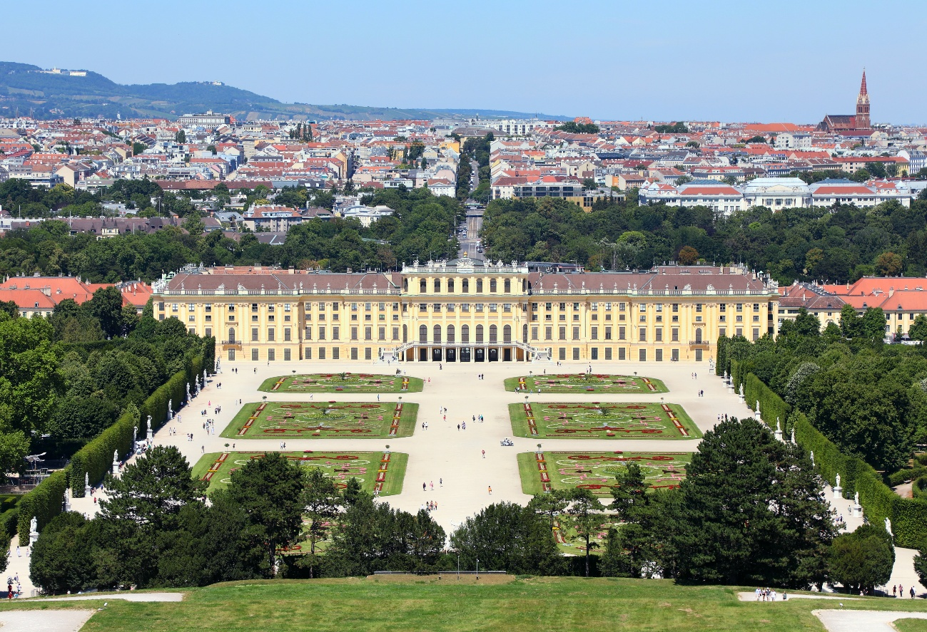

South view of the Schönbrunn Palace and park © C.Stadler/Bwag; CC-BY-SA-4.0